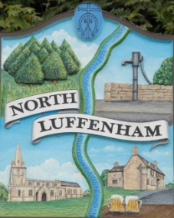
All Councillors are summoned to the Parish Council (Trust) Meeting immediately following the Parish Council Meeting on
North Luffenham Parish Council
Wednesday, 18th of October 2023 – NL Community Centre.

Agenda

77/23 Acceptance of apologies for absence
78/23 Declarations of Interest
79/23 To approve and sign Minutes:
Parish Council (Trust) meeting 20th of September 2023 [Document]
80/23 Correspondence
- Allotment Plots
- Lease agreement – For Bowls club and Cricket club
- Dog Poo Bins
- Bonfire Night – Free Firewood
- Oval Trees – Lime trees causing damage
81/23 Finance Report

- To receive, consider and approve the Finance Report: [Document]
- To approve the following payments:
- Ionos - £6
- Four Counties Ground Maintenance – £315
- Four Counties Ground Maintenance Sept - £105
- Mow All - £240

82/23 Field Gardens Report - Cllr Cade

Allotments

Woodland Walk

83/23 Oval Report - Cllr Cade

84/23 Fireworks
- Update
- Posts
- Invoices/Quotes

85/23 Date of next meeting: 15th November 2023
immediately following the NLPC meeting

Jadene Bale, Parish Clerk

