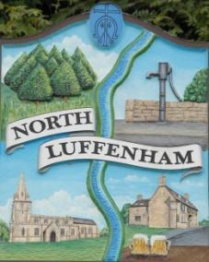
All Councillors are summoned to the Parish Council Meeting on Wednesday, 15th of November 2023 at 19:00 - NL Community Centre.
North Luffenham Parish Council

Agenda

171/23 Apologies

172/23 Declarations of Interest

173/23 Public Forum

174/23 To approve and sign Minutes as follows:

- Parish Council meeting 18th of October 2023 [Document]

175/23 Ward Report

176/23 Chairman’s Report

177/23 Correspondence

- Request for memorial tree.

- Broken Bin

- Damage to housing in village due to traffic.

- Grass cutting and tidying up of village spaces.

- North Luffenham Village Trust – New Trustee

- ICO – Direct Debit

- Requests for Electoral Register 2024 RCC

- Defib Fund

- Mum Group

- Mobile Vaccinations Team

178/23 Finance Report:
- To receive, consider and approve the Finance Report [Document]:
- To approve the following payments:
- Clerk’s Salary – £679.17 (£543.37 Net and 135.80 HMRC)
- Zen – £42.00
- Community Centre Electrical Meter – £729.95
- ICO - £35.00

179/23 Planning - Cllr Burrows

180/23 To receive and consider the report from the Community Centre Management Committee – Cllr Cade

181/23 To receive and consider the report from the CIL Group – Cllr Burrows

182/23 Neighbourhood Plan

183/23 Community Service Award

184/23 Village Website

185/23 North Luffenham Youth Parish Council

186/23 Backdated Local government Pay/Clerk Salary Scale review

187/23 Date of next meeting: 20th December 2023

Jadene Bale, Parish Clerk

