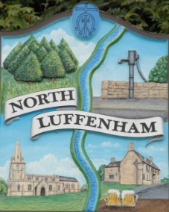
All Councillors are summoned to the Parish Council (Trust) Meeting immediately following the Parish Council Meeting on
North Luffenham Parish Council
Wednesday, 15th of November 2023 – NL Community Centre.

Agenda

86/23 Acceptance of apologies for absence
87/23 Declarations of Interest
88/23 To approve and sign Minutes:
Parish Council (Trust) meeting 18th of October 2023 [Document]
89/23 Correspondence
- Allotment Plots
- Lease agreement – For Bowls club and Cricket club
- Dog Poo Bins
- Bonfire Night – Free Firewood
- Oval Trees – Lime trees causing damage (2 properties)
90/23 Fireworks
- Approval of further expenditure
- Report
91/23 Finance Report

- To receive, consider and approve the Finance Report: [Document]
- To approve the following payments:
- Ionos - £6.00
- Glow Sticks – Cllr Burrows - £29.75
- Events Licence – Cllr Burrows - £21.00
- Loudhailer – Cllr Gorse - £44.17
- Batteries – Cllr Gorse - £12.99
- Sparklers – Cllr Cade - £409.00
- Kitchen Stand Costs – Cllr Cade - £70.16
- Mulled Wine Stand Costs – Cllr Cade - £189.78
- Mileage – Cllr Cade - £35.55 (£0.45 x 79 miles)
- Ground Stakes – Cllr Cade - £187.20
- Mow All - £240.00
- 4 Counties - £315.00

92/23 Field Gardens Report - Cllr Cade

Allotments

Woodland Walk

93/23 Oval Report - Cllr Cade

94/23 Date of next meeting: 20th December 2023
immediately following the NLPC meeting

Jadene Bale, Parish Clerk

