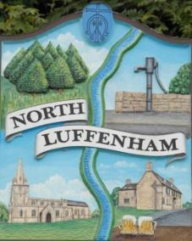
All Councillors are summoned to the Parish Council Meeting on Wednesday, 20th of December 2023 at 19:00 - NL Community Centre.
North Luffenham Parish Council

Agenda

188/23 Apologies

189/23 Declarations of Interest

190/23 Public Forum

191/23 To approve and sign Minutes as follows:

- Parish Council meeting 15th of November 2023 [Document]

192/23 Ward Report

193/23 Chairman’s Report

194/23 Correspondence

- Request for memorial tree.

- Broken Bin

- Damage to housing in village due to traffic.

- Grass cutting and tidying up of village spaces.

- Defib Fund

- PCC Invite

195/23 Finance Report:
- To receive, consider and approve the Finance Report [Document]:
- To approve the following payments:
- Clerk’s Salary – £1109.30 (£880.14 Net and 229.16 HMRC) inclusive of backpay
- Zen – £42.00
- RCC – Street Lighting - £2591.49
- Woody Electrical – £679.95

196/23 Planning - Cllr Burrows

197/23 To receive and consider the report from the Community Centre Management Committee – Cllr Cade

198/23 To receive and consider the report from the CIL Group – Cllr Burrows

199/23 Neighbourhood Plan/Local Plan

200/23 Community Service Award

201/23 Village Website

202/23 North Luffenham Youth Parish Council

203/23 Clerk Salary Scale review

204/23 Budget/Precept

205/23 Date of next meeting: 17th January 2024

Jadene Bale, Parish Clerk

