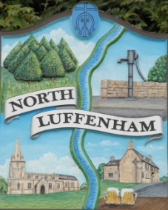
All Councillors are summoned to the Parish Council (Trust) Meeting immediately following the Parish Council Meeting on
North Luffenham Parish Council
Wednesday, 20th of December 2023 – NL Community Centre.

Agenda

95/23 Acceptance of apologies for absence
96/23 Declarations of Interest
97/23 To approve and sign Minutes:
Parish Council (Trust) meeting 15th of November 2023 [Document]
98/23 Correspondence
- Allotment Plots – Renewal Letters and Applications
- Lease agreement – For Bowls club and Cricket club
- Dog Poo Bins
- Oval Trees – Lime trees causing damage (2 properties)
99/23 Finance Report

- To receive, consider and approve the Finance Report: [Document]
- To approve the following payments:
- Ionos - £6.00
- Fireworks - £1440
- WaterPlus – TBC

100/23 Field Gardens Report - Cllr Cade

Allotments

Woodland Walk

101/23 Oval Report - Cllr Cade

102/23 Budget

103/23 Date of next meeting: 17th January 2024
immediately following the NLPC meeting

Jadene Bale, Parish Clerk

