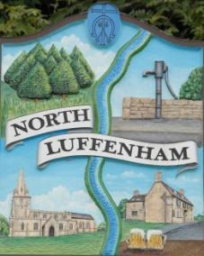
All Councillors are summoned to the Parish Council Meeting on Wednesday, 24th of January 2024 at 19:00 - NL Community Centre.
North Luffenham Parish Council

Agenda

01/24 Apologies

02/24 Declarations of Interest

03/24 Public Forum

04/24 To approve and sign Minutes as follows:

- Parish Council meeting 20th of December 2023 [Document]

05/24 Ward Report

06/24 Chairman’s Report

07/24 Correspondence

- Application for memorial tree and bench.

- Broken Bin

- Tidying up of village spaces.

- Defib Fund

- Payroll

08/24 Finance Report:
- To receive, consider and approve the Finance Report [Document]:
- To approve the following payments:
- Clerk’s Salary – £726.96 (£581.56 Net and 145.40 HMRC)
- Zen – £42.00

09/24 Planning - Cllr Burrows

10/24 To receive and consider the report from the Community Centre Management Committee – Cllr Cade

11/24 To receive and consider the report from the CIL Group – Cllr Burrows

12/24 Local Plan

13/24 Community Service Award

14/24 Village Website

15/24 North Luffenham Youth Parish Council

16/24 Date of next meeting: 21st February 2024

Jadene Bale, Parish Clerk

