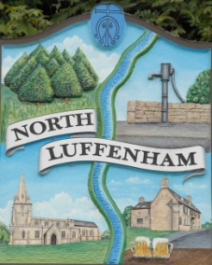
All Councillors are summoned to the Parish Council (Trust) Meeting immediately following the Parish Council Meeting on
North Luffenham Parish Council
Wednesday, 24th of January 2024 – NL Community Centre.

Agenda

01/24 Acceptance of apologies for absence
02/24 Declarations of Interest
03/24 To approve and sign Minutes:
Parish Council (Trust) meeting 20th of December 2023 [Document]
04/24 Correspondence
- Allotment Plots – Renewal Letters and Applications
- Lease agreement – For Bowls club and Cricket club
- Dog Poo Bins
- Oval Trees – Lime trees causing damage (2 properties)
- Quad Bikes on Oval
05/24 Finance Report

- To receive, consider and approve the Finance Report: [Document]
- To approve the following payments:
- Ionos - £6.00
- WaterPlus – £46.64
- Slate Allotment Signs- £77.40

06/24 Field Gardens Report - Cllr Cade

Allotments

Woodland Walk

07/24 Oval Report - Cllr Cade

08/24 Date of next meeting: 21st February 2024
immediately following the NLPC meeting

Jadene Bale, Parish Clerk

