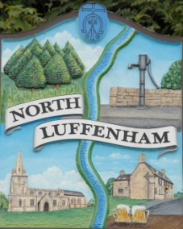
Allotment Application Form
Please complete the form below and sign the attached terms and conditions form in order to be placed on our waiting list. Please note that you will be placed on the waiting list after receipt of both forms. The waiting list is not first come; first served. The trust has a priority system which may mean, dependant on your circumstances, that you will be offered an allotment later than others who apply at the same time.

Name
Date
Telephone Number
Address

(inc. Postcode)
Email address
Please indicate which size plot you would like? | (full, half quarter or any size plot)
Allotment Holders | Do you already hold an allotment/have you held an allotment previously in North Luffenham?
Do you have access to a garden?
Are you wanting to keep chickens on the allotment?
Other factors you may wish for us to consider? | E.g. using allotment for charitable/educational purposes

