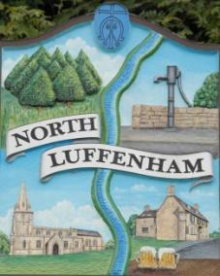
All Councillors are summoned to the Parish Council Meeting on Wednesday, 21st of February 2024 at 19:00 - NL Community Centre.
North Luffenham Parish Council

Agenda

17/24 Apologies

18/24 Declarations of Interest

19/24 Public Forum

20/24 To approve and sign Minutes as follows:

- Parish Council meeting 24th of January 2024 [Document]

21/24 Ward Report

22/24 Chairman’s Report

23/24 Correspondence

- Application for memorial tree and bench.

- Broken Bin

- Tidying up of village spaces

- Defib Fund

- Payroll

- Jetties Street Lighting

- Bluestone (Pilton Solar Farm)

- Grant for PCC

24/24 Finance Report:
- To receive, consider and approve the Finance Report [Document]:
- To approve the following payments:
- Clerk’s Salary – £755.74 (£604.54 Net and 151.20 HMRC)
- Zen – £42.00

25/24 Planning - Cllr Burrows

26/24 To receive and consider the report from the Community Centre Management Committee – Cllr Cade

27/24 To receive and consider the report from the CIL Group – Cllr Burrows

28/24 Community Service Award

29/24 Date of next meeting: 20th March 2024

Jadene Bale, Parish Clerk

