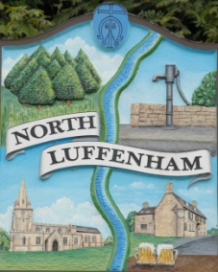
All Councillors are summoned to the Parish Council (Trust) Meeting immediately following the Parish Council Meeting on
North Luffenham Parish Council
Wednesday, 21st of January 2024 – NL Community Centre.

Agenda

09/24 Acceptance of apologies for absence
10/24 Declarations of Interest
11/24 To approve and sign Minutes:
Parish Council (Trust) meeting 24th of January 2024 [Document]
12/24 Correspondence
- Lease agreement – For Bowls club and Cricket club
- Oval Trees – Lime trees causing damage (2 properties)
13/24 Finance Report

- To receive, consider and approve the Finance Report: [Document]
- To approve the following payments:
- Ionos - £6.00
- WaterPlus – £46.64

14/24 Field Gardens Report - Cllr Cade

Allotments

Woodland Walk

15/24 Oval Report - Cllr Cade

Playground Equipment Repairs

16/24 Date of next meeting: 20th March 2024
immediately following the NLPC meeting

Jadene Bale, Parish Clerk

