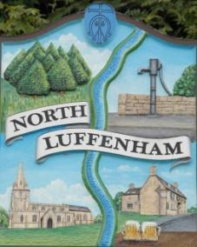
All Councillors are summoned to the Parish Council Meeting on Wednesday, 20th of March 2024 at 19:00 - NL Community Centre.
North Luffenham Parish Council

Agenda

30/24 Apologies

31/24 Declarations of Interest

32/24 Public Forum

33/24 Co-option of Councillor following the resignation of Cllr Marsh.

34/24 To approve and sign Minutes as follows:

- Parish Council meeting 21st of February 2024 [Document]

35/24 Ward Report

36/24 Chairman’s Report

37/24 Correspondence

- Application for memorial tree and bench.

- Broken Bin

- Tidying up of village spaces

- Defib Fund

- Payroll

- Jetties Street Lighting

- Bluestone (Pilton Solar Farm)

- Grant for PCC

- Alicia Kearns – response to our complaint regarding the lack of distinction between the councillor signing in favour and other councils who have voted to sign as a whole council.

- Request for funding – LP NHS Trust – Sensory Room.

38/24 Finance Report:
- To receive, consider and approve the Finance Report [Document]:
- To approve the following payments:
- Clerk’s Salary – £739.87 (£591.87 Net and 148.00 HMRC)
- Zen – £42.00
- RCC – Green Waste Bin - £60.00
- ICO - £35.00

39/24 Planning - Cllr Burrows

40/24 To receive and consider the report from the Community Centre Management Committee – Cllr Cade

41/24 To receive and consider the report from the CIL Group – Cllr Burrows

42/24 Community Service Award

43/24 Bank Mandate – ONLINE HSBC

44/24 Date of next meeting: Annual Parish Meeting - 17th April 2024

Jadene Bale, Parish Clerk

