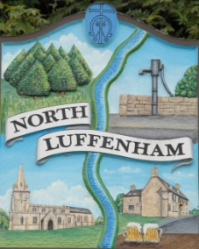
All Councillors are summoned to the Parish Council (Trust) Meeting immediately following the Parish Council Meeting on
North Luffenham Parish Council
Wednesday, 20th of March 2024 – NL Community Centre.

Agenda

17/24 Acceptance of apologies for absence
18/24 Declarations of Interest
19/24 To approve and sign Minutes:
Parish Council (Trust) meeting 21st of February 2024 [Document]
20/24 Correspondence
- Lease agreement – For Bowls club and Cricket club
- Oval Trees – Lime trees causing damage (2 properties)
21/24 Finance Report

- To receive, consider and approve the Finance Report: [Document]
- To approve the following payments:
- Ionos - £7.20
- WaterPlus – £29.51
- Mow all – Last Payment for 23/24 – £240.00

22/24 Field Gardens Report - Cllr Cade

Allotments

Woodland Walk

23/24 Oval Report - Cllr Cade

24/24 Date of next meeting: 17th April 2024
immediately following the NLPC meeting

Jadene Bale, Parish Clerk

