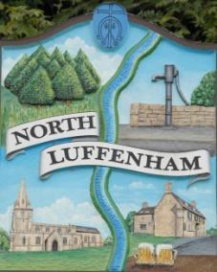
All Councillors are summoned to the Parish Council Meeting on Wednesday, 17th of April 2024 at 19:30 - NL Community Centre.
North Luffenham Parish Council

Agenda

45/24 Apologies

46/24 Declarations of Interest

47/24 Public Forum

48/24 To approve and sign Minutes as follows:

- Parish Council meeting 20th of March 2024 [Document]

49/24 Ward Report

50/24 Chairman’s Report

51/24 Correspondence

- Application for memorial tree and enquiry

- Broken Bin

- Defib Fund

- Bluestone (Pilton Solar Farm)

- Grant for PCC

- Grass cutting

52/24 Finance Report:
- To receive, consider and approve the Finance Report [Document]:
- To approve the following payments:
- Clerk’s Salary – £TBC
- Zen – £42.00
- End of Payroll - £39.00

53/24 Planning - Cllr Burrows

54/24 To receive and consider the report from the Community Centre Management Committee – Cllr Cade

41/24 To receive and consider the report from the CIL Group – Cllr Burrows

42/24 Community Service Award - Feedback

43/24 Date of next meeting: TBC May 2024

Jadene Bale, Parish Clerk

