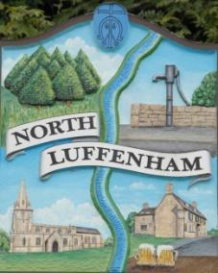
You are all invited to the Annual Parish Meeting on Wednesday 17th of April 2023 at 19.00 - NL Community Centre.
North Luffenham Parish Council

Agenda

- Chairman’s Report from Cllr Tim Smith
- Financial Report from Clerk of NLPC
- General Items for discussion/residents’ concerns
- Reports from village organisations and groups
- Awarding the first NL annual Community Service Award
- Any other business

Jadene Bale, Parish Clerk

