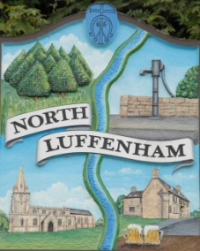
All Councillors are summoned to the Parish Council (Trust) Meeting immediately following the Parish Council Meeting on
North Luffenham Parish Council
Wednesday, 17th of April 2024 – NL Community Centre.

Agenda

25/24 Acceptance of apologies for absence
26/24 Declarations of Interest
27/24 To approve and sign Minutes:
Parish Council (Trust) meeting 20th of March 2024 [Document]
28/24 Correspondence
- Tree Inspection Quotes
29/24 Finance Report

- To receive, consider and approve the Finance Report: [Document]
- To approve the following payments:
- Ionos - £7.20

30/24 Field Gardens Report - Cllr Cade

Allotments
WaterPlus account is in credit.

Woodland Walk

Including report of fire

31/24 Oval Report - Cllr Cade

32/24 Date of next meeting: TBC May 2024
immediately following the NLPC meeting

Jadene Bale, Parish Clerk

