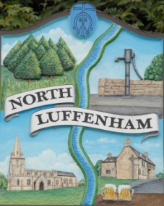
All Councillors are summoned to the Parish Council (Trust) Meeting immediately following the Parish Council Meeting on
North Luffenham Parish Council
Tuesday, 9th of May 2024 at 19:30 – NL Community Centre.

Agenda

33/24 Election of Chair
34/24 Election of Vice Chair
35/24 Acceptance of apologies for absence
36/24 Declarations of Interest
37/24 To review Committees and Working Groups for 2024/2025
- Oval/Field Working Group
38/24 To approve and sign Minutes:

Parish Council (Trust) meeting 17th of April 2024 [Document]

39/24 Correspondence

- Tree Inspection Quotes

40/24 Finance Report

- To receive, consider and approve the Finance Report: [Document]
- To approve the following payments:
- Ionos - £6
- The Rutland Handyman - £450
- Allotment Insurance - £13.00

41/24 Field Gardens Report - Cllr Cade

Allotments

Woodland Walk

42/24 Oval Report - Cllr Cade

43/24 Date of next meeting: TBC

Jadene Bale, Parish Clerk

