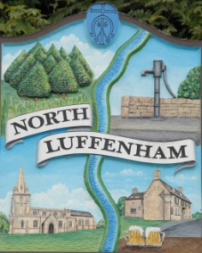

North Luffenham Parish Council

A parish council (trust) meeting for North Luffenham Parish Council will be held immediately following the full Parish Council meeting on 15th October 2025, in the NL Community Centre.

All members of the council are hereby summoned to attend for the purpose of considering and resolving upon the business to the be transacted at the meeting as set out hereunder.

Amy Lord

08/10/2025

**Agenda**

**51/25 To receive and approve apologies for absence**

**52/25 Declarations of Interest**

**53/25** **To approve and sign Minutes:**

53.1 To receive, approve and sign Minutes of the previous meeting held on 17th September 2025.

**54/25 Matters arising from previous minutes – Please refer to actions in red.**

**55/25 Correspondence**

**56/25** **Finance Report**

* 1. To receive, consider and approve the Finance Report.
  2. To approve the following payments:
* Little Miss Mow All; Invoice 32 £260.00
* 4 Counties Ground Maintenance; Invoice 25/081 £345.00



**57/25 Field Gardens Report - Cllr Cade + Allotment Society**

57.1 Allotments

57.2 National Allotment Society Payment

57.3 To review and approve the updated Allotments Rules and Tenant Agreement.

57.4 To receive quotes for wooden posts and cork for the notice board for allotments.

57.5 Woodland Walk

57.6 Bowls Club Lease

* To approve the appointment of a solicitor.

**58/25 Oval Report - Cllr Cade**

**59/25 Waterplus Invoices**

59.1 To review waterplus invoices

**60/25 Grass Cutting**

**61/25** **Date of next meeting: TBC**