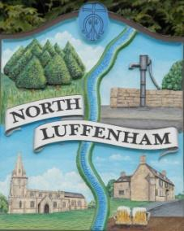
North Luffenham Parish Council

Agenda
19th November 2025

A full parish council meeting for North Luffenham Parish Council will be held on 19th November 2025 at 7pm in the NL Community Centre.

All members of the council are hereby summoned to attend for the purpose of considering and resolving upon the business to the be transacted at the meeting as set out hereunder.

Amy Lord
13/11/2025
Amy Lord – Clerk and Responsible Finance Officer.

112/25 Public Forum

113/25 To receive ward report.

-------------------- Meeting officially commences ----------------

114/25 To receive and approve apologies for absence.

115/25 To receive declarations of interest.

116/25 To receive, approve and sign Minutes of the previous meeting held on 15th October 2025.

116.1 Chair to sign the minutes from the council meeting on 15th October 2025

117/25 Matters arising from previous minutes.

118/25 Chairman’s report.

119/25 Correspondence and reports from other meetings

120/25 Policies
120.1 To review and approve the updated TOR’s
- CIL Working group TOR
- Finance Working Group TOR
- Neighbourhood Plan TOR
- Staffing Working Group TOR
- IT Working Group TOR

121/25 Finance Report:
121.1 To receive, consider and approve the bank reconciliations.
121.2 To approve the following payments on payment schedule below:

122/25 Planning
122.1 To review and comment on current planning applications

123/25 Community Centre
123.1 To receive and consider the report from the Community Centre Management Committee – Cllr Cade

124/25 To receive and consider the report from the CIL Group – Cllr Burrows

125/25 Bonfire night update

126/25 Working groups and committees

127/25 AGAR task list for Clerk and Councillors

128/25 Items for next agenda

129/25 Date of next meeting: 17th December, 21st January, 21st January, 18th February, 18th March.

