North Luffenham Parish Council

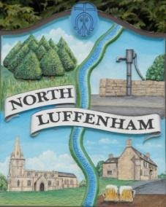
A parish council (trust) meeting for North Luffenham Parish Council will be held immediately following the full Parish Council meeting on 19th November 2025, in the NL Community Centre.

All members of the council are hereby summoned to attend for the purpose of considering and resolving upon the business to the be transacted at the meeting as set out hereunder.

Amy Lord
13/11/2025

Agenda

62/25 To receive and approve apologies for absence

63/25 Declarations of Interest

64/25 To approve and sign Minutes:
64.1 To receive, approve and sign Minutes of the previous meeting held on 15th October 2025.

65/25 Matters arising from previous minutes – Please refer to actions in red.

66/25 Correspondence

67/25 Finance Report
67.1 To receive, consider and approve the Finance Report.
67.2 To approve the following payments:
- J Gregg – notice board reimbursement £71.29

68/25 Field Gardens Report - Cllr Cade + Allotment Society
45.1 Allotments
45.2 Woodland Walk
45.3 Bowls Club Lease

69/25 Oval Report - Cllr Cade

70/25 Date of next meeting: 17th December, 21st January, 18th February, 18th March.
Page 2 of 2

