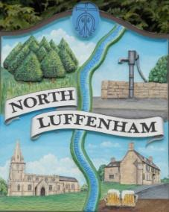
North Luffenham Parish Council

Agenda
17th December 2025

A full parish council meeting for North Luffenham Parish Council will be held on 17th December 2025 at 7pm in the NL Community Centre.

All members of the council are hereby summoned to attend for the purpose of considering and resolving upon the business to the be transacted at the meeting as set out hereunder.

Amy Lord
10/12/2025
Amy Lord – Clerk and Responsible Finance Officer.

130/25 Public Forum

131/25 To receive ward report.

-------------------- Meeting officially commences ----------------

132/25 To receive and approve apologies for absence.

133/25 To receive declarations of interest.

134/25 To receive, approve and sign Minutes of the previous meeting held on 19th November 2025.

134.1 Chair to sign the minutes from the council meeting on 19th November 2025

135/25 Matters arising from previous minutes.

136/25 To declare a casual vacancy due to non-attendance of a councillor.

137/25 Chairman’s report.

138/25 Correspondence and reports from other meetings

139/25 Policies
139.1 To review and approve the updated TOR’s
- Youth Council Working group TOR
- Community Centre Working Group TOR
- Bonfire Night Working Group TOR

140/25 Finance Report:
140.1 To receive, consider and approve the bank reconciliations.
140.2 To approve the following payments on payment schedule below:

141/25 Planning
141.1 To review and comment on current planning applications
2025/1443/FUL. 3 The Barn, Settings Farm, Pilton Road, North Luffenham, Rutland LE15 9PD. Installation of a First Floor casement window to the East elevation to match existing.

142/25 Community Centre
142.1 To receive and consider the report from the Community Centre Management Committee – Cllr Cade

143/25 To receive and consider the report from the CIL Group – Cllr Burrows

144/25 Working groups and committees

145/25 AGAR task list for Clerk and Councillors
145.1 Correction to Minutes of 20 November 2024. To consider and resolve a correction to the approved minutes of the meeting held on 20 November 2024, in relation to the attendance and apologies recorded, as requested following the AGAR review.

146/25 Items for next agenda

147/25 Date of next meeting: 21st January, 18th February, 18th March.

