North Luffenham Parish Council

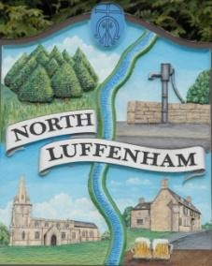
A parish council (trust) meeting for North Luffenham Parish Council will be held immediately following the full Parish Council meeting on 17th December 2025, in the NL Community Centre.

All members of the council are hereby summoned to attend for the purpose of considering and resolving upon the business to the be transacted at the meeting as set out hereunder.

Amy Lord
10/12/2025

Agenda

71/25 To receive and approve apologies for absence

72/25 Declarations of Interest

73/25 To approve and sign Minutes:
73.1 To receive, approve and sign Minutes of the previous meeting held on 19th November 2025.

74/25 Matters arising from previous minutes – Please refer to actions in red.

75/25 Correspondence
75.1 Charrington Tree Services confirmed that the planning permission for the tree cutting has been applied for.

76/25 Finance Report
76.1 To receive, consider and approve the Finance Report.
76.2 To approve the following payments:
- Four counties ground maintenance Inv 25/097 £345.00
- Four counties ground maintenance Inv 25/111 £345.00

77/25 Field Gardens Report - Cllr Cade + Allotment Society
45.1 Allotments
45.2 Woodland Walk
45.3 Bowls Club Lease

78/25 Oval Report - Cllr Cade

79/25 Date of next meeting: 21st January, 18th February, 18th March.

