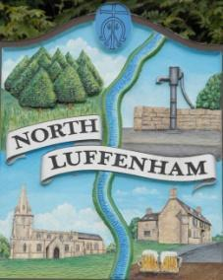
North Luffenham Parish Council

Agenda
21st January 2026

A full parish council meeting for North Luffenham Parish Council will be held on 21st January 2026 at 7pm in the NL Community Centre.

All members of the council are hereby summoned to attend for the purpose of considering and resolving upon the business to the be transacted at the meeting as set out hereunder.

Amy Lord
12/01/2026
Amy Lord – Clerk and Responsible Finance Officer.

148/25 Public Forum

149/25 To receive ward report.

-------------------- Meeting officially commences ----------------

150/25 To receive and approve apologies for absence.

151/25 To receive declarations of interest.

152/25 To receive, approve and sign Minutes of the previous meeting held on 17th December 2025.

152.1 Chair to sign the minutes from the council meeting on 17th December 2025

153/25 Matters arising from previous minutes.

154/25 Chairman’s report.

155/25 Correspondence and reports from other meetings
155.1 Email Rutland Local Plan Examination - Post Hearings Consultation circulated prior to meeting.

156/25 Policies
156.1 To review and approve the IT policy.

157/25 Finance Report:
157.1 To receive, consider and approve the bank reconciliations.
157.2 To approve the following payments on payment schedule below:
157.3 To review and approve the financial regulations
157.4 To approve LRALC internal audit service

158/25 Planning
To review and comment on current planning applications
158.1 2025/1647/CAT. 9 Church Street North Luffenham Rutland LE15 8JR. (T1) 1 no. Silver birch to be crown reduced by approximately 2m and 1- 1.5m on the sides. (T2)(T3) 2 no. Holly to be reduced in height by approximately 1.5 meters.

159/25 Community Centre
159.1 To receive and consider the report from the Community Centre Management Committee – Cllr Cade

160/25 To receive and consider the report from the CIL Group – Cllr Burrows

161/25 Working groups and committees
162.1 To discuss the neighbourhood plan report.

162/25 AGAR task list for Clerk and Councillors

163/25 Items for next agenda

164/25 Date of next meeting: 18th February, 18th March, 15th April, 20th May, 17th June.

