North Luffenham Parish Council

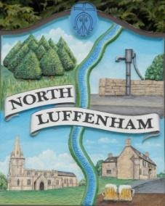
A parish council (trust) meeting for North Luffenham Parish Council will be held immediately following the full Parish Council meeting on 21st January 2026, in the NL Community Centre.

All members of the council are hereby summoned to attend for the purpose of considering and resolving upon the business to the be transacted at the meeting as set out hereunder.

Amy Lord
12/01/2026

Minutes

80/25 To receive and approve apologies for absence

81/25 Declarations of Interest

82/25 To approve and sign Minutes:
73.1 To receive, approve and sign Minutes of the previous meeting held on 17th December 2025.

83/25 Matters arising from previous minutes – Please refer to actions in red.

84/25 Correspondence
84.1 Email regarding water supply at allotments.

85/25 Finance Report
85.1 To receive, consider and approve the Finance Report.
85.2 To approve the following payments:

86/25 Field Gardens Report - Cllr Cade + Allotment Society
86.1 Allotments
86.2 Woodland Walk
86.3 Bowls Club Lease

87/25 Oval Report - Cllr Cade

88/25 Date of next meeting: 18th February, 18th March.

