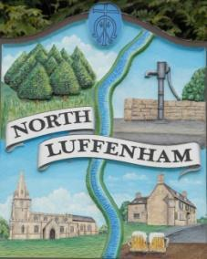
North Luffenham Parish Council

Agenda
18th February 2026

A full parish council meeting for North Luffenham Parish Council will be held on 18th February 2026 at 7pm in the NL Community Centre.

All members of the council are hereby summoned to attend for the purpose of considering and resolving upon the business to the be transacted at the meeting as set out hereunder.

Amy Lord
09/02/2026
Amy Lord – Clerk and Responsible Finance Officer.

165/25 Public Forum

166/25 To receive ward report.

-------------------- Meeting officially commences ----------------

167/25 To receive and approve apologies for absence.

168/25 To receive declarations of interest.

169/25 To receive, approve and sign Minutes of the previous meeting held on 21st January 2026.

169.1 Chair to sign the minutes from the council meeting on 21st January 2026.

170/25 Matters arising from previous minutes.

171/25 Chairman’s report.

172/25 Correspondence and reports from other meetings
172.1 Community speed watch scheme
172.2 Notification from RCC that no election has been called following the notice of vacancy. Council are now clear to co-opt.

173/25 Finance Report:
173.1 To receive, consider and approve the bank reconciliations.
173.2 To approve the following payments on payment schedule below:
173.3 To review and approve the financial regulations.

174/25 Planning
To review and comment on current planning applications

175/25 Community Centre
176.1 To receive and consider the report from the Community Centre Management Committee – Cllr Cade

176/25 To receive and consider the report from the CIL Group – Cllr Burrows

177/25 Working groups and committees

178/25 AGAR task list for Clerk and Councillors

179/25 Items for next agenda

180/25 To resolve to move into confidential session in accordance with the Public Bodies (Admission to Meetings) Act 1960, to discuss a confidential contractual matter.

181/25 Date of next meeting: 18th March, 15th April, 20th May, 17th June.

