North Luffenham Parish Council

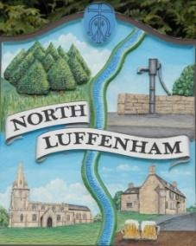
A parish council (trust) meeting for North Luffenham Parish Council will be held immediately following the full Parish Council meeting on 18th February 2026, in the NL Community Centre.

All members of the council are hereby summoned to attend for the purpose of considering and resolving upon the business to the be transacted at the meeting as set out hereunder.

Amy Lord
09/02/2026

Agenda

89/25 To receive and approve apologies for absence

90/25 Declarations of Interest

91/25 To approve and sign Minutes:
91.1 To receive, approve and sign Minutes of the previous meeting held on 21st January 2026.

92/25 Matters arising from previous minutes – Please refer to actions in red.

93/25 Correspondence
93.1 To discuss options and quotes received for repairing or replacing the fencing around the play area.

94/25 Finance Report
94.1 To receive, consider and approve the Finance Report.
94.2 To approve the following payments:

95/25 Field Gardens Report - Cllr Cade + Allotment Society
86.1 Allotments
86.2 Woodland Walk
86.3 Bowls Club Lease

96/25 Oval Report - Cllr Cade

97/25 Charity Sleepout
97.1 To consider and approve permission for a charity sleepover event to be held at the Oval.

98/25 Date of next meeting: 18th March, 15th April, 20th May.

