Frequently Asked Questions

Why is our waste and recycling service changing?

The UK Government has said that all councils must introduce a separate food waste collection service in 2026. This change also supports Rutland County Council’s aim of improving local recycling rates, reducing residual waste and meeting national requirements for more sustainable waste management.

Why should I recycle my food waste?
Food waste is 70% water. Sending food waste for incineration requires a lot of energy to burn, so recycling is a better method of disposal. It’s much greener and cheaper.

How often will my food waste be collected?
Food waste will be collected from the kerbside outside your home every week. This means your food waste will no longer be left sitting in your black wheelie bin for two weeks at a time. This is an improved service and means black bins will be cleaner, lighter and less full.

Will there be changes to my usual refuse and recycling collections once separate food waste collections are introduced?
The only change you will see to your normal bin collections is the switch to a smaller black wheelie bin and the introduction of separate weekly food waste collections from 30 March onwards. Your grey recycling bin will stay the same size and there is no change to any of your bin collection days. There won’t be any change to assisted collections, either. We’ll come to empty your grey recycling bin, smaller black bin and green bin (if you have one) on the same day we’ve always done. All you need to do to empty your outdoor food caddy each week is present it next to your grey or black bin.

What if I don’t produce any food waste?
No amount of food waste is too small. The best thing we can do with our food is enjoy it but some waste like banana skins, vegetable peelings, tea bags and bones are unavoidable. All of these can be recycled in your food waste caddy.

When and how will I receive my new, smaller black bin?

We’re going to start replacing 240litre black bins with smaller 140litre bins from

Monday 2 March 2026 onwards. The process is simple and will coincide with your normal black bin collection day.

Just keep putting your black household waste bin out for collection, as normal. At some point in March, we’ll empty it, take it away and replace it with your new, smaller black bin. We’ll do this all in one go, so that your old bin is emptied, removed and replaced at the same time, on a normal black bin collection day. We plan to complete all bin swaps by 30 March.

Because you’re getting a brand-new black bin, it won’t have any stickers or house numbers on it, so you may want to purchase these before March, to make sure
you’re ready.

Please note, food waste caddies will not arrive with your new black bin – these will be delivered separately in March.

When and how will I receive my new kitchen and outdoor caddies for
food waste?

We’ll start to deliver your new food waste caddies from Monday 9 March, ready for weekly food waste collections to begin from Monday 30 March. Households will get two caddies: a small kitchen caddy to keep indoors and a larger caddy that stays outside. Both caddies will be delivered at the same time, during March, and left on the kerbside outside your property. The smaller caddy will be placed securely inside the larger caddy, along with a written guide that explains how to use them both correctly.

Will the Council collect additional side waste if new, smaller black bins are being used before food waste collections begin?

Yes. Because you may be left with a smaller black bin for a short period before new food waste collections start, we will be accepting one bag of side waste with 140litre black bin collections between 2 and 27 March. Any side waste needs to be fully bagged and presented next to your smaller black bin, on the day of your collection.

What should I do if I don’t receive my new black bin or food waste caddies?

We are planning to carry out bin swaps and food caddy deliveries for whole streets at once. If you see smaller black bins and food caddies being delivered to your neighbours and haven’t received yours by the end of the next working day, please report this to us online, using your Rutland County Council MyAccount. Just select the option to report a general waste issue: www.rutland.gov.uk/myaccount. Alternatively, you can email: enquiries@rutland.gov.uk or call: 01572 722 577.

What will change for people who use communal bins?

We won’t be replacing the household waste bins that are shared by residents living in flats, apartment blocks and other similar properties. However, we are working with housing associations and property managers to arrange delivery of individual food waste caddies. Caddy deliveries to these buildings may not happen until after March.

What can be included in my food waste bin?
All food waste can be disposed of in your new food waste bin, including uneaten food and plate scrapings:
- All uneaten food | - Bones | - Beans and pulses
- Plate scrapings | - Cheese and yogurt | - Raw vegetables
- Raw meat | - Eggs and eggshells | - Cooked vegetables
- Cooked meat | - Tea bags | - Whole fruit and fruit pieces
- Raw fish | - Coffee grounds | - Fruit and veg peelings
- Cooked fish | - Rice and pasta | - Pet food

You will be able to recycle any mouldy and out of date food, including ready meals that have been removed from their packaging.
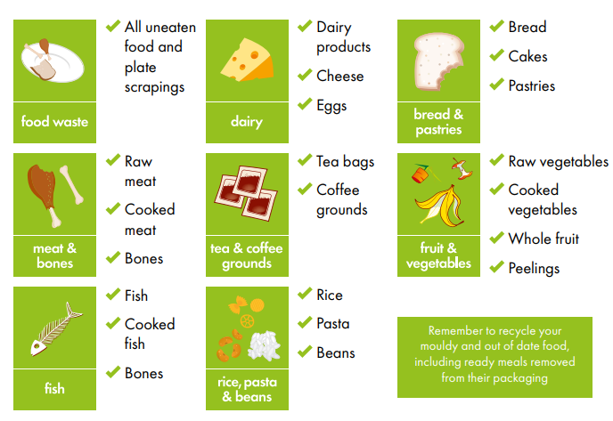

What can’t be recycled as food waste?

We don’t want anything that isn’t food. It helps to remember that these are food waste collections – not general kitchen waste. We only want unpackaged food placed in biodegradable caddy liners:
- No liquids such as milk
- No oils or liquid fat
- No kitchen towels or cleaning wipes
- No plastic or metal coffee pods
- No packaging of any kind

How do I recycle food waste?

Start by putting a biodegradable liner in your small kitchen caddy, then place your food waste inside. Whenever you need to empty your small kitchen caddy, just tie the top of your liner and put the bagged food waste into your larger outdoor caddy, ready for collection.

You can use a different food waste container inside your home, instead of the small kitchen caddy we provide. However, you must use your larger outdoor caddy with lockable lid for weekly kerbside collection. Place the larger outdoor caddy next to your black or grey wheelie bin on your normal bin collection day and we’ll take the bagged food waste away.

Do I have to use a biodegradable liner or bag inside my kitchen caddy?

Yes. To keep the small 7litre kitchen caddy clean and sanitary, all residents need to line them with biodegradable waste sacks – also referred to as food waste bags or caddy liners. These are available to buy online or from local supermarkets.

Using liners will help to keep your kitchen caddy clean and make it easier for you to dispose of your food waste – particularly when transferring food waste into the larger outdoor caddy. It’s important to make sure food waste liners or sacks are biodegradable, so please check the product description or label carefully, when you purchase them.

Please don’t use unsuitable alternatives to line your food waste caddies, such as black bin bags or carrier bags from the supermarket. This may lead to food waste being rejected at the processing plant, because it is contaminated with plastic.

Can I put food waste straight into my larger outdoor caddy?

Food waste can be placed straight into your large outdoor caddy, as long as you use a biodegradable liner. These liners are available in a range of sizes. The size of your outdoor food waste caddy is 23litres.

Will separating food waste lead to nasty smells indoors?
No. Your small kitchen caddy will hold food waste that would have previously gone into your kitchen bin, so there should be no difference in smell. Your small kitchen caddy can sit on a worktop, under your kitchen sink, or wherever is most convenient. You’ll use it to hold any food scraps, peelings, tea bags etc. then tie up the caddy liner and place the bag into your larger outdoor caddy whenever you feel necessary (similar to how you would empty your kitchen bin and take the waste to your outdoor wheelie bin). Food waste caddies are also dishwasher proof, so can be thoroughly cleaned as and when necessary.

Will the outdoor food caddy attract rats or other animals?
The outdoor caddy is made from similar plastic as your current wheelie bins. The lid is also designed to lock in place, to prevent it spilling or being opened by animals. It’s very rare that people have problems with rats getting into their wheelie bins to eat food waste. If you don’t have any problems with rats getting into your wheelie bin now, you shouldn’t have any problems with your outdoor food waste caddy. The caddy is more secure than a wheelie bin, because it is lockable.

How will I cope with a smaller black bin?

We know that, on average, 43% of the waste in black wheelie bins is food waste. These black bins are currently collected every two weeks. Introducing a weekly food waste collection will free up space in black bins and mean that a smaller 140litre bin is big enough for any remaining household waste that needs to be thrown away.
Having looked at what’s going into people’s black bins, we also know households are throwing away some materials that could be recycled in their grey bins. The introduction of weekly food waste collections and the move to a smaller black bin is a good time to check what should be going into your grey recycling bin, freeing up even more space inside black bins.
We are not introducing any new or different recycling containers – all dry mixed recycling will continue to go in your grey wheelie bin. Check the grey bin guide on our website to see what can be recycled in Rutland: www.rutland.gov.uk/recycling

Will there be allowances for larger families and those with medical needs?

Yes. We will continue to provide extra capacity for larger families and those with medical needs. We are also introducing a new category of additional household waste capacity for families who have children in nappies, if they need it. From early March you can request additional household waste capacity using your Rutland County Council MyAccount. You can also email: enquiries@rutland.gov.uk or call: 01572 722 577. Anyone can request an additional grey bin in the same way, if they produce a lot

of recycling.

Is it costing the Council money to make these changes?
There is a cost to making this change. However, there is also an opportunity for the Council and Rutland residents to save money. Food waste is heavy and holds a lot of water. This makes it expensive for councils to transport and incinerate. Recycling food waste is a lot cheaper than getting rid of it in black household waste bins. If enough people use the new food waste service, it will reduce Rutland County Council’s waste disposal costs, and we can look to pass this saving on to residents. Sending less
waste for incineration also has a positive impact on the environment by reducing harmful emissions.

Where will Rutland’s food waste go after it’s been collected?
All of the food waste collected in Rutland will be transported to a nearby anaerobic digestion facility. This is a special process where bacteria break down the food waste to produce biogas and fertiliser for farmland. The biogas can then be used to generate renewable heat and power.

What will happen with the larger 240litre black bins that are taken away?
The old bins we collect will be recycled or reused somewhere else.

How will this be impacted by local government reorganisation?
Local government reorganisation won’t have any impact on these changes. All councils – including any new authorities created by local government reorganisation – need to provide separate food waste collections from 2026, because of changes to the law.

