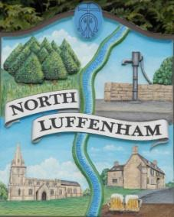
North Luffenham Parish Council

Agenda
18th March 2026

A full parish council meeting for North Luffenham Parish Council will be held on 18th March 2026 at 7pm in the NL Community Centre.

All members of the council are hereby summoned to attend for the purpose of considering and resolving upon the business to the be transacted at the meeting as set out hereunder.

Amy Lord
09/03/2026
Amy Lord – Clerk and Responsible Finance Officer.

182/25 Public Forum

183/25 To receive ward report.

-------------------- Meeting officially commences ----------------

184/25 To receive and approve apologies for absence.

185/25 To receive declarations of interest.

186/25 To receive, approve and sign Minutes of the previous meeting held on 18th February 2026.

186.1 Chair to sign the minutes from the council meeting on 18th February 2026.

187/25 Matters arising from previous minutes.

188/25 Chairman’s report.

189/25 Correspondence and reports from other meetings

190/25 Finance Report:
190.1 To receive, consider and approve the bank reconciliations.
190.2 To approve the following payments on payment schedule below:

191/25 Planning
To review and comment on current planning applications

192/25 Community Centre
192.1 To receive and consider the report from the Community Centre Management Committee – Cllr Cade

193/25 To receive and consider the report from the CIL Group – Cllr Burrows

194/25 Working groups

195/25 CiLCA

196/25 Items for next agenda

197/25 Date of next meeting: 15th April, 20th May, 17th June.

