North Luffenham Parish Council

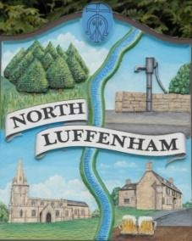
A parish council (trust) meeting for North Luffenham Parish Council will be held immediately following the full Parish Council meeting on 18th March 2026, in the NL Community Centre.

All members of the council are hereby summoned to attend for the purpose of considering and resolving upon the business to the be transacted at the meeting as set out hereunder.

Amy Lord
09/03/2026

Agenda

99/25 To receive and approve apologies for absence

100/25 Declarations of Interest

101/25 To approve and sign Minutes:
101.1 To receive, approve and sign Minutes of the previous meeting held on 18th February 2026.

102/25 Matters arising from previous minutes – Please refer to actions in red.

103/25 Correspondence
103.1 To discuss options and quotes received for repairing or replacing the fencing around the play area.
103.2 To discuss request for permission to plant a memorial tree at the Oval.

104/25 Finance Report
104.1 To receive, consider and approve the Finance Report.
104.2 To approve the following payments:

105/25 Field Gardens Report - Cllr Cade + Allotment Society
105.1 Allotments
105.2 Woodland Walk
105.3 Bowls Club Lease

106/25 Oval Report - Cllr Cade

108/25 Date of next meeting: 15th April, 20th May.

