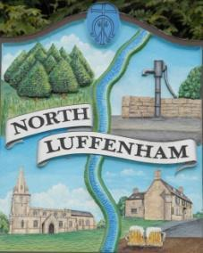
North Luffenham Parish Council

Agenda
15th April 2026

A full parish council meeting for North Luffenham Parish Council will be held on 15th April 2026 at 7pm in the NL Community Centre.

All members of the council are hereby summoned to attend for the purpose of considering and resolving upon the business to the be transacted at the meeting as set out hereunder.

Amy Lord
08/04/2026
Amy Lord – Clerk and Responsible Finance Officer.

1/26 Public Forum

2/26 To receive ward report.

-------------------- Meeting officially commences ----------------

3/26 To receive and approve apologies for absence.

4/26 To receive declarations of interest.

5/26 To receive, approve and sign Minutes of the previous meeting held on 18th March 2026.
5.1 Chair to sign the minutes from the council meeting on 18th March 2026.

6/26 Matters arising from previous minutes.

7/26 Chairman’s report.

8/26 Correspondence and reports from other meetings

9/26 Finance Report:
9.1 To receive, consider and approve the bank reconciliations.
9.2 To approve the following payments on payment schedule below:

10/26 Planning
10.1 2026/0370/CAT. 22 Kings Road North Luffenham Rutland LE15 8JH. T1 - Pine - Remove part-snapped limb of Pine tree, remove low limb growing towards house, thin large low branch by 25% over driveway - these works will reduce the risk of limb failure over driveway

11/26 Community Centre
11.1 To receive and consider the report from the Community Centre Management Committee – Cllr Cade

12/26 To receive and consider the report from the CIL Group
12.1 To receive update from CIL meeting held 9th April.

13/26 Working groups

14/26 To discuss flooding on Moore Lane

15/26 To resolve to exclude the press and public from the meeting and move into closed session due to the confidential nature of the business to be transacted.

16/26 Items for next agenda

17/26 Date of next meeting: 20th May, 17th June.

