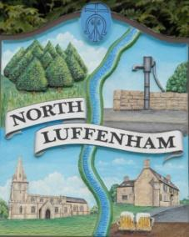
North Luffenham Parish Council

Agenda
15th April 2026

The Annual Parish Meeting for North Luffenham Parish Council will be held on 15th April 2026 at 6.30pm in the NL Community Centre.

All members of the council are hereby summoned to attend for the purpose of considering and resolving upon the business to the be transacted at the meeting as set out hereunder.

Amy Lord
09/04/2026
Amy Lord – Clerk and Responsible Finance Officer.

1/26 Chairman’s Welcome

2/26 Chairman’s Report – Cllr Tim Smith

3/26 Financial Report – Clerk / Responsible Finance Officer

4/26 Reports from village organisations and groups

5/26 General items for discussion / residents’ concerns

6/26 Any other business

