North Luffenham Parish Council

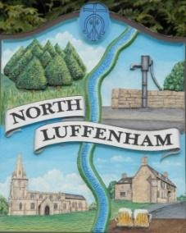
A parish council (trust) meeting for North Luffenham Parish Council will be held immediately following the full Parish Council meeting on 15th April 2026, in the NL Community Centre.

All members of the council are hereby summoned to attend for the purpose of considering and resolving upon the business to the be transacted at the meeting as set out hereunder.

Amy Lord
08/04/2026

Agenda

1/26 To receive and approve apologies for absence

2/26 Declarations of Interest

3/26 To approve and sign Minutes:
3.1 To receive, approve and sign Minutes of the previous meeting held on 18th March 2026.

4/26 Matters arising from previous minutes – Please refer to actions in red.

5/26 Correspondence
5.1 To discuss the representative of the Village Trust.

6/26 Finance Report
6.1 To approve the following payments
6.2 To check bank reconciliation

7/26 Field Gardens Report - Cllr Cade + Allotment Society
7.1 Allotments
7.2 Woodland Walk
7.3 Bowls Club Lease

8/26 Oval Report - Cllr Cade

9/26 Date of next meeting: 20th May.

