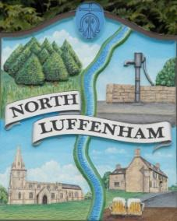
North Luffenham Parish Council

Parish Council Annual Meeting
Agenda
20th May 2026

The Parish Council Annual Meeting for North Luffenham Parish Council will be held on 20th May 2026 at 7pm in the NL Community Centre.

All members of the council are hereby summoned to attend for the purpose of considering and resolving upon the business to the be transacted at the meeting as set out hereunder.

Amy Lord
13/05/2026
Amy Lord – Clerk and Responsible Finance Officer.

18/26 Public Forum

19/26 To receive ward report.

-------------------- Meeting officially commences ----------------

20/26 To elect Chair
20.1 Chair to sign declaration of acceptance.

21/26 To elect Vice Chair
21.1 Vice Chair to sign declaration of acceptance.

22/26 To receive and approve apologies for absence.

23/26 To receive declarations of interest.

24/26 Co-option of Councillor
24.1 To sign declaration of acceptance.

25/26 To receive, approve and sign Minutes of the previous meeting held on 15th April 2026.
5.1 Chair to sign the minutes from the council meeting on 15th April 2026.

26/26 Matters arising from previous minutes.

27/26 Chairman’s report.

28/26 Correspondence and reports from other meetings
28.1 Chater club bowls report received.
28.2 Email from Moores estate agents re valuation signage around the village.

29/26 Finance Report:
29.1 To receive, consider and approve the bank reconciliations.
29.2 To approve the following payments on payment schedule below:

30/26 Planning

31/26 Community Centre
31.1 To receive and consider the report from the Community Centre Management Committee – Cllr Cade

32/26 To receive and consider the report from the CIL Group

33/26 Working groups

34/26 To resolve to exclude the press and public from the meeting and move into closed session due to the confidential nature of the business to be transacted.

35/26 Items for next agenda

36/26 Date of next meeting: 17th June, 15th July.

