North Luffenham Parish Council

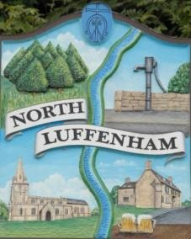
A parish council (trust) meeting for North Luffenham Parish Council will be held immediately following the full Parish Council meeting on 20th May 2026, in the NL Community Centre.

All members of the council are hereby summoned to attend for the purpose of considering and resolving upon the business to the be transacted at the meeting as set out hereunder.

Amy Lord
11/05/2026

Agenda

09/26 To receive and approve apologies for absence

10/26 Declarations of Interest

11/26 To approve and sign Minutes:
11.1 To receive, approve and sign Minutes of the previous meeting held on 15th April 2026.

12/26 Matters arising from previous minutes – Please refer to actions in red.

13/26 Correspondence

14/26 Finance Report
14.1 To approve the following payments
14.2 To check bank reconciliation

15/26 Field Gardens Report - Cllr Cade + Allotment Society
7.1 Allotments
7.2 Woodland Walk
7.3 Bowls Club Lease

16/26 Oval Report - Cllr Cade

17/26 Date of next meeting: 17th June.

