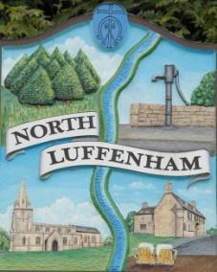
North Luffenham Parish Council

Agenda
17th June 2026

A full parish council meeting for North Luffenham Parish Council will be held on 17th June 2026 at 7pm in the NL Community Centre.

All members of the council are hereby summoned to attend for the purpose of considering and resolving upon the business to the be transacted at the meeting as set out hereunder.

Amy Lord
11/06/2026
Amy Lord – Clerk and Responsible Finance Officer.

37/26 Public Forum

38/26 To receive ward report.

-------------------- Meeting officially commences ----------------

39/26 To receive and approve apologies for absence.

40/26 To receive declarations of interest.

41/26 To receive, approve and sign Minutes of the previous meeting held on 20th May 2026.

41.1 Chair to sign the minutes from the council meeting on 20th May 2026

42/26 Matters arising from previous minutes.

43/26 Chairman’s report.

44/26 Correspondence and reports from other meetings

45/26 Policies

46/26 Finance Report:
46.1 To receive, consider and approve the bank reconciliations.
46.2 To approve the following payments on payment schedule below:

47/26 – AGAR
47.1 To receive and note the Internal Auditor's Report for the year ended 31 March 2026.
47.2 To review and approve the Annual Governance Statement 2025/26 (AGAR Section 1).
47.3 To review and approve the Accounting Statements 2025/26 (AGAR Section 2).
47.4 To note the dates for the exercise of public rights – Monday 22nd June – Friday 31st July.

48/26 Planning

49/26 Community Centre
49.1 To receive and consider the report from the Community Centre Management Committee – Cllr Cade
49.2 To consider options for the future management and occupation of the Community Centre.

50/26 To receive and consider the report from the CIL Group – Cllr Burrows

51/26 Working groups and committees

52/26 Meeting Dates
52.1 To confirm upcoming meeting dates

53/26 Items for next agenda

54/26 Date of next meeting: 15th July.

