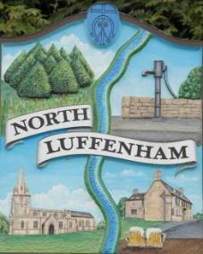
North Luffenham Parish Council

Agenda
15th July 2026

A full parish council meeting for North Luffenham Parish Council will be held on 15th July 2026 at 7pm in the NL Community Centre.

All members of the council are hereby summoned to attend for the purpose of considering and resolving upon the business to the be transacted at the meeting as set out hereunder.

Amy Lord
09/07/2026
Amy Lord – Clerk and Responsible Finance Officer.

55/26 Public Forum

56/26 To receive ward report.

-------------------- Meeting officially commences ----------------

57/26 To receive and approve apologies for absence.

58/26 To receive declarations of interest.

59/26 To receive, approve and sign Minutes of the previous meeting held on 17th June 2026.

59.1 Chair to sign the minutes from the council meeting on 17th June 2026

60/26 Matters arising from previous minutes.

61/26 Chairman’s report.

62/26 Correspondence and reports from other meetings
62.1 Email from resident regarding the location of the memorial tree.

63/26 Policies
63.1 To review standing orders.

64/26 Finance Report:
64.1 To receive, consider and approve the bank reconciliations.
64.2 To approve the following payments on payment schedule below:

65/26 Planning
65.1 2026/0712/LBA. The Old Rectory 8 Church Street North Luffenham Rutland LE15 8JR. Installation of through floor lift.

66/26 Community Centre
49.1 To receive and consider the report from the Community Centre Management Committee – Cllr Cade

67/26 To receive and consider the report from the CIL Group – Cllr Burrows

68/26 Working groups and committees

69/26 Items for next agenda

70/26 Date of next meeting: 19th August

