North Luffenham Parish Council

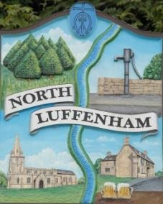
A parish council (trust) meeting for North Luffenham Parish Council will be held immediately following the full Parish Council meeting on 15th July 2026, in the NL Community Centre.

All members of the council are hereby summoned to attend for the purpose of considering and resolving upon the business to the be transacted at the meeting as set out hereunder.

Amy Lord
09/07/2026

Agenda

27/26 To receive and approve apologies for absence

28/26 Declarations of Interest

29/26 To approve and sign Minutes:
29.1 To receive, approve and sign Minutes of the previous meeting held on 17th June 2026.

30/26 Matters arising from previous minutes – Please refer to actions in red.

31/26 Correspondence
31.1 Email received re damaged stone wall at the Oval.

32/26 Finance Report
32.1 To approve the following payments
32.2 To check bank reconciliation

33/26 Field Gardens Report - Cllr Cade + Allotment Society
33.1 Allotments
33.2 Woodland Walk
33.3 Bowls Club Lease

34/26 Oval Report - Cllr Cade

35/26 Date of next meeting: 19th August.

