North Luffenham Parish Council

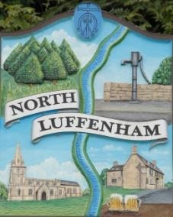
A parish council (trust) meeting for North Luffenham Parish Council was held immediately following the full Parish Council meeting on 19th August 2026, in the NL Community Centre.

Present; Cllr Smith, Cllr Gorse, Cllr Forbes, Cllr Spiegl, Cllr Collins, Cllr Cade, Cllr Purves.

Minutes

36/26 To receive and approve apologies for absence
Cllr Burrows, Cllr Waller, A.Lord (clerk) all sent their apologies. Approved in full council meeting.

37/26 Declarations of Interest
None.

38/26 To approve and sign Minutes:
38.1 The minutes of the previous meeting held on 15th July 2026 were circulated prior to the meeting, it was agreed to sign the minutes, proposed Cllr Forbes, seconded Cllr Collins. (4 abstentions due to absence from previous meeting)

39/26 Matters arising from previous minutes – Please refer to actions in red.
Clerk had circulated a list of the completed tasks from the previous minutes. Cllr Cade advised the Oval had been mowed. The repair of the wall at the Oval has been completed.

40/26 Correspondence
None.

41/26 Finance Report
41.1 The payments presented were approved. Proposed by Cllr Spiegl, seconded by Cllr Gorse, all agreed.
The Clerk had advised that additional funds would need to be transferred to the Field Gardens Trust current account to cover forthcoming expenditure, including hedge cutting, bramble clearance and tree works. Following discussion, it was agreed to transfer £5,000 to the Trust current account to ensure sufficient funds were available. Proposed by Cllr Collins, seconded by Cllr Cade, all agreed.
41.2 To check bank reconciliation – this was checked against the online banking during the meeting and confirmed. Proposed Cllr Gorse, seconded Cllr Collins, all agreed.

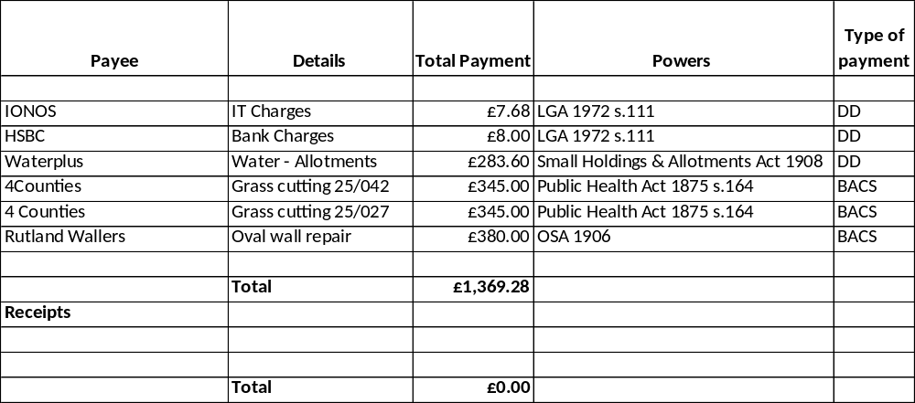

42/26 Field Gardens Report - Cllr Cade + Allotment Society
42.1 Allotments – report received from J Gregg, nothing to approve.
42.2 Woodland Walk – it was agreed for Cllr Cade to speak to G.Bull to cut the brambles back and up to £400 was agreed to be spent for the work. Cllr Spiegl proposed, Cllr Forbes seconded.
42.3 Bowls Club Lease – draft lease received and sent to Cllr Burrows. As Cllr Burrows was not at the meeting it was decided to carry this over to the next meeting.
42.4 Bowls Club Area of the Allotments – Valuation
To consider requesting a quotation from Richardsons of Stamford for a valuation of the Bowls Club area of the allotments, to establish its current market value. All agreed to approve a request for the quotation.

43/26 Oval Report - Cllr Cade
Rutland Wallers have repaired the wall – invoice on payment list was approved.

44/26 Playground equipment damage
It was reported that the bottom three panels of the climbing frame edges are all delaminated and the bolts are starting to wear through. It was decided that a quote is to be requested from Wicksteed.

45/26 Bonfire Night planning
It was agreed that the council will hold a Bonfire night this year and that a Bonfire committee meeting would be organised.

46/26 Tree works to be carried out.
To consider the three quotations received for the tree works identified in the tree inspection report and agree the contractor to undertake the works. The councillors discussed the 3 quotes received and accepted the quote from T.Plummer at £2760 plus £160 for removal of wood. Proposed Cllr Spiegl, seconded Cllr Cade.

47/26 Date of next meeting; 16th September.

Close of meeting; 21.03pm

